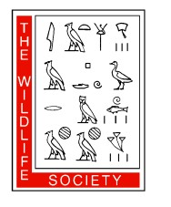
Canadian Section of TWS Student Travel Award Application
CS Annual General Meeting in Winnipeg, MB

16‒17 March 2018
Application Deadline: 2 February 2018

Contact Information

Name (Last, First) Email Address Mailing Address Address Continued University
Degree Sought

Expected or Actual
Graduation Date

Presentation Information

Will you be giving the presentation?
Type of Presentation
Are you the senior author?
Have you received a CSTWS Travel Award in the
last year?
Yes
Poster Yes Yes
No
Oral Presentation No
No

Summary of Conference Travel Budget

Air travel | $ ____________
Vehicle travel | $ ____________
Accommodations | $ ____________
Conference registration | $ ____________
Total projected costs | $ ____________
Funding from other sources | $ ____________
Funding requested from the Canadian Section | $ ____________

Verification

The undersigned assure that the information supplied on the previous page and on attached documents is true, that the applicant meets the eligibility requirements as stated herein, and that the financial need as stated is accurate.

Student Signature Date

Advisor Signature Date

Please submit this full application form PLUS a copy of your abstract for your presentation/poster to nicola.koper@umanitoba.ca with the subject line: CS Travel Award 2017.

