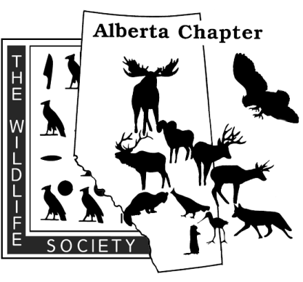
Mail to:
Alberta Chapter of The Wildlife Society
Box 4990
Edmonton, Alberta
T6E 5GS
CONFERENCE REGISTRATION FORM
2018 Annual General Meeting and Conference
Lethbridge Lodge, Lethbridge, Alberta. March 9-11, 2018

Registrant – All Fields required. One form per registrant
Name:
Organization:
Address: |  |  |  | Postal Code:
City/Town: |  | Province: |  | Phone:
E-mail (required to receive Chapter Newsletters and access to Membership Portal):

REGISTRATION
Category | Price | Quantity | Total
Membership – Regular | $20.00
Membership – Student | $5.00
Registration–includes 1 Banquet Ticket (Cash or Cheque only)
Regular Member (Early-Bird) – Deadline January 14, 2018 | $250.00
Student Member (Early-Bird) – Deadline January 14, 2018 | $100.00
Regular Member - Deadline February 16, 2018 | $300.00
Student Member - Deadline February 16, 2018 | $150.00
Registration subtotal
Extra Saturday Banquet Tickets  A limited number of banquet tickets are available for extra guests. These include dinner, guest speaker, auction, and after dinner entertainment on 18 March 2017 | $50.00/ea
FINAL TOTAL
*GST is excluded on all prices as The Alberta Chapter of the Wildlife Society operates as a non-profit and does not charge for gst

