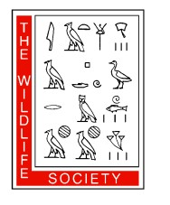
Alberta Chapter and Canadian Section of TWS

Student Travel Award Application
Joint Conference in Canmore, Alberta, 22–24 March 2019

Application Deadline: 5 February 2019

Contact Information

Name (Last, First) Email Address Mailing Address Address Continued University
Degree Sought

Expected or Actual
Graduation Date

Presentation Information

Will you be giving the presentation?
Type of Presentation
Are you the senior author?
Have you received an ACTWS or CSTWS Travel Award in the last year?
Yes
Poster
Yes
Yes
No
Oral Presentation No
No

Summary of Conference Travel Budget

Air travel | $ ____________
Vehicle travel | $ ____________
Accommodations | $ ____________
Conference registration | $ ____________
Total projected costs | $ ____________
Funding from other sources | $ ____________
Funding requested from the Alberta Chapter and Canadian Section of TWS | $ ____________

Verification

The undersigned assure that the information supplied on the previous page and on attached documents is true, that the applicant meets the eligibility requirements as stated herein, and that the financial need as stated is accurate.

Student Signature Date

Advisor Signature Date

Please submit this full application form PLUS a copy of your abstract for your presentation/ poster to director4@actws.ca and winikessler@gmail.com with the subject line: Student Travel Award.

